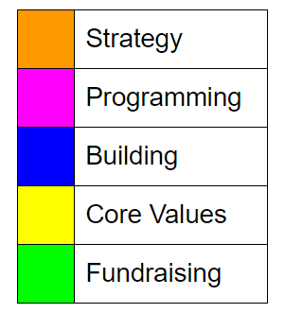

Practice Schedule

|  |  |
| --- | --- |
| 5:00 - 5:10 | Set-Up (board, mission models) |
| 5:10 - 5:20 | Stand-Up |
| 5:30 - 6:40 | Practice ! |
| 6:40 - 6:50 | Retrospection |
| 6:50 - 7:00 | Clean-Up |